Adrian Turion |  | Avenue de Sainte-Clotilde 9  1205 Geneva, Switzerland | 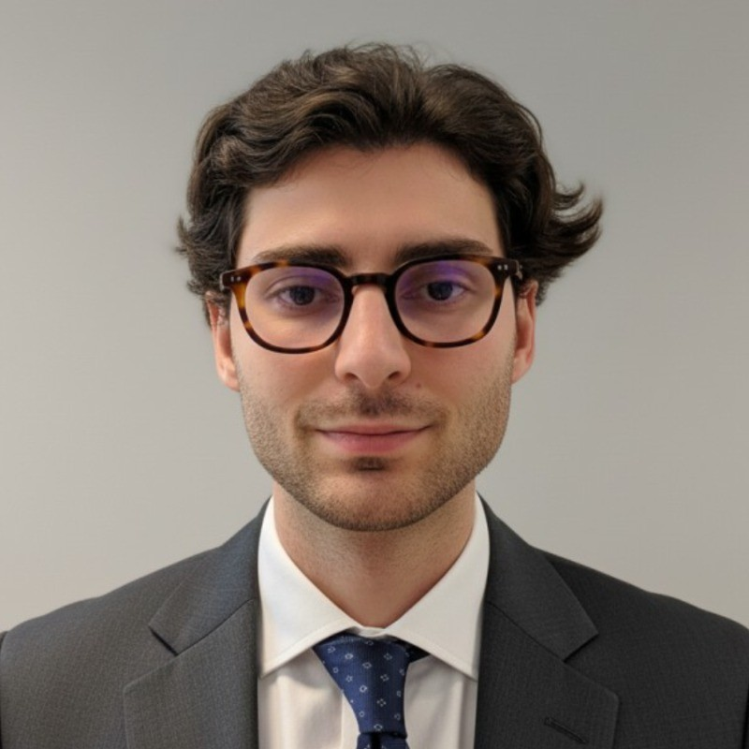
turionadrian@gmail.com | Swiss national | 10.11.2000 |  | +41 77 262 37 96
INTRODUCTION
Investment and M&A analyst based in Geneva with cross-border small & mid-cap experience in Europe, strong financial modelling and valuation skills, and exposure to healthcare, tech and industrial sectors. Keen to transition to a long-term, multi-asset investment role within a single-family office, combining rigorous analysis, portfolio thinking and data-driven processes.
WORK EXPERIENCE
Auraïa Capital Advisory – Small & Mid Cap Cross-border M&A Boutique  Mergers & Acquisitions Analyst (Converted internship into full-time position) |  | Geneva, Switzerland  Aug 2024 – Current
- Analyse and evaluate small & mid-cap companies in healthcare, tech & software, services and industrials across Switzerland and Europe, producing detailed company profiles, sector mappings and financial models to support investment and transaction decisions
- Build integrated valuation models (DCF, trading and transaction comparables, LBO, scenarios and sensitivities) and prepare clear written materials (teasers, information memorandums, presentations) used by entrepreneurs, investors and boards
- Implement data- and AI-driven processes to systematise target and investor screening, maintain dynamic deal and company databases and improve monitoring of opportunities and counterparties over time

RC Group – Currently under LBO with Crédit Mutuel Equity  Mergers & Acquisitions Intern |  | Paris, France  Feb 2024 – Aug 2024
- Supported the CEO of the Healthcare & Retail division in designing and executing a buy-and-build strategy, screening over 180 European targets, engaging with management teams and contributing to investment analyses and recommendation memos

Europ Assistance – Subsidiary of Generali Insurance  Financial Analyst Intern |  | Geneva, Switzerland  Apr 2023 – Aug 2023
- Built P&L models and three-year forecasts for a portfolio of ~CHF 20m B2B contracts, monitored performance against budget and prepared concise reports for the CFO to support profitability, pricing and strategic decisions

LEADERSHIP
- Finalist – Keyrock x McKinsey 2024: co-developed a quantitative model using order book and market data to forecast disruption scenarios and presented strategic recommendations under time pressure to Keyrock leadership and McKinsey partners
- Associate – AIESEC: relaunched post-COVID business development by sourcing corporate leads, producing tailored pitchbooks and negotiating three partnerships (~CHF 60k), significantly increasing volunteer placements
EDUCATION
HEC Lausanne  Master of Science in Finance |  | Lausanne, Switzerland  2021 – 2024
- Cumulative GPA: 5.2/6.0 (Top 15% of the class cohort)
- Exchange programs at Waseda University (Tokyo, Japan) and Maastricht University (Maastricht, Netherlands)
- Relevant Coursework: Corporate Finance, Valuation, M&A, Private Equity, Venture Capital
- Thesis Topic: Synergies Analysis of the Merger between American Airlines & US Airways

Bachelor of Science in Management |  | 2018 – 2021
- Cumulative GPA: 4.7/6.0

Scientific Baccalaureate (French National Baccalauréat) - Highest Honors (16.6/20) |  | Aix-en-Provence, France
ADDITIONAL INFORMATION
Languages:  Computer:  Interests:  References: | French (Native, C2), Spanish (Native, C2), English (Fluent, C1)  German (business proficient – currently strengthening ahead of relocation to Zurich in 2026)  Excel, PowerPoint, Bloomberg, FactSet, Capital IQ, VBA, various AI tools (screening, data gathering and process automation)  Fitness, badminton, philosophy, real-life applications of Artificial Intelligence, financial markets and macroeconomics, venture and growth investing, sustainable technologies  Guillaume Arnaldez – Ex-Director at Auraïa Capital Advisory, guillaume.arnaldez@auraia.ch

